UPSELL CAMPAIGN – VF4
The Upsell Campaign Performance – VF4 Panel project is a full data-driven growth initiative that delivered a major revenue uplift and earned an Employee of the Month award. It combines Snowflake data-mart design, SQL segmentation, Power BI reporting and cross-functional stakeholder management.
Business outcome
- Targeted existing customers for an upsell to a new VF4 panel, achieving around 62% conversion from contacted to accepted/installed customers.
- Drove a revenue uplift of roughly £30M potential revenue from this campaign, focusing effort on the most relevant, high-value accounts.
- Embedded the process into BAU: the RPA team used the curated upsell list to automatically create tickets for Customer Care agents, ensuring consistent execution at scale.

End-to-end flow
Data sources → Snowflake Upsell Datamart (SQL rules) → Upsell list → RPA ticket creation → Customer Care calls → Customer acceptance → Installer visits & installation → Invoicing → Power BI Upsell Dashboard.
- Built a dedicated Snowflake data mart (documented in upsell.docx) that brings together customer, product, contract and maintenance data.
- Wrote SQL segmentation and exclusion rules to:
  - Identify eligible customers for VF4 upsell (device profile, system age, contract status, engagement, etc.).
  - Remove customers who should not be contacted (recent cancellations, credit issues, technical constraints, open complaints).
- Generated a prioritised upsell list which the RPA team used to create tickets in the Customer Care system, so agents always worked from a clean, validated queue.
- After customer acceptance, installers received jobs, installed the panel and triggered invoicing, closing the revenue loop.
Power BI and stakeholder reporting
- Designed the Upsell Campaign Performance Power BI dashboard showing:
  - Top-level funnel metrics: Fast maintenances, exclusions, opportunities, tickets opened, contacted, accepted, declined, installations, not installed and invoiced.
  - Key KPIs: Contacted rate, Conversion rate, Installation rate, all implemented as reusable, filter-aware DAX measures.
  - Weekly trend lines for Opportunities vs Contacted and Scheduled maintenances vs Opportunities to understand operational capacity and campaign timing.
- Built the report for senior stakeholders in Operations, Marketing, Customer Care and Installations, enabling them to monitor performance by date range, detect bottlenecks (e.g., contact rate vs opportunities) and refine targeting or staffing.
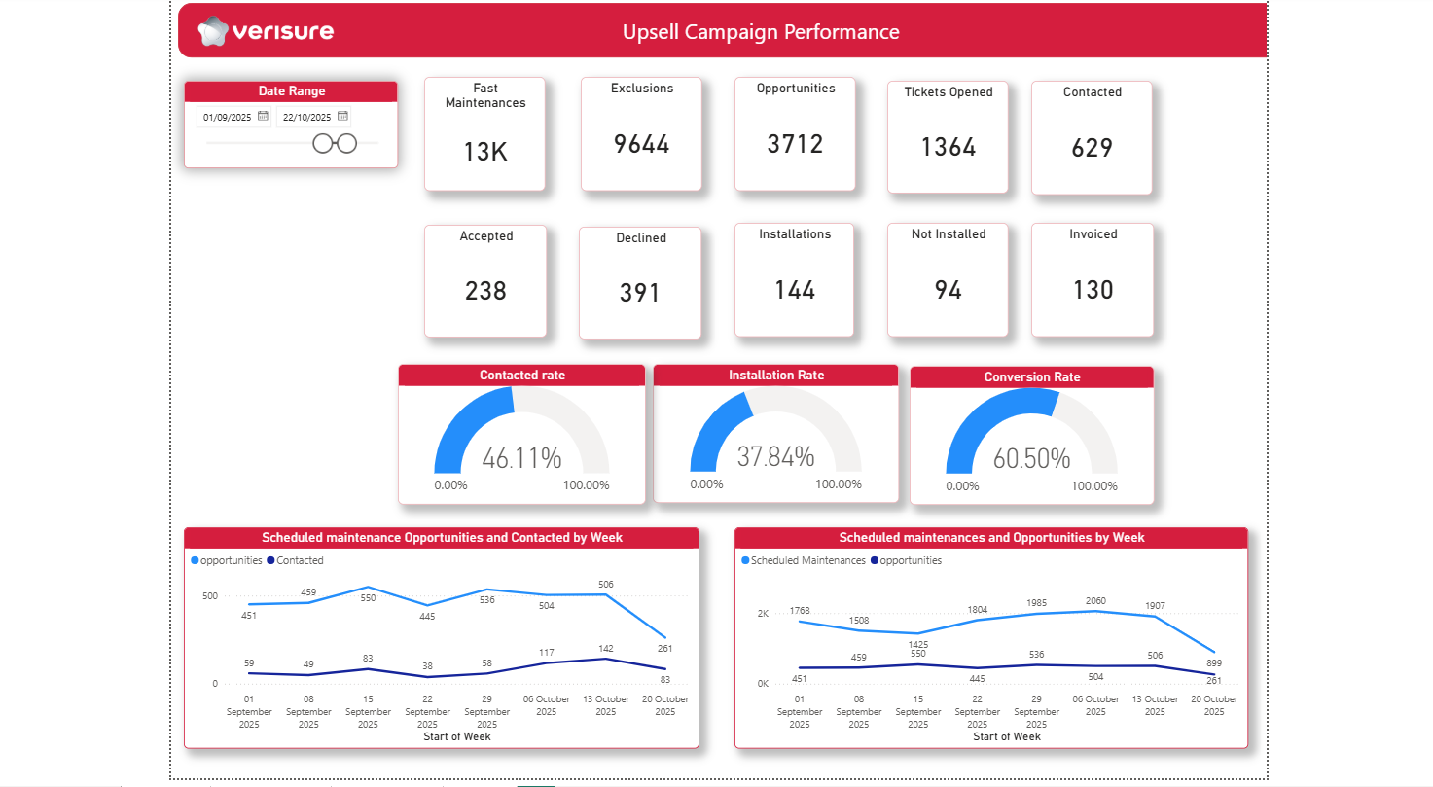
Skills demonstrated
- SQL & Snowflake: data-mart design, complex eligibility/exclusion logic, scalable segmentation for 150k+ customers.
- Power BI: KPI modelling, funnel analytics, clear executive UX and time-series analysis of campaign performance.
- Automation & operations: collaboration with the RPA team to operationalise the upsell list into tickets, ensuring data products directly drive frontline action.
- Stakeholder management: partnering with Customer Operations, Customer Marketing, Customer Care and Installations to define rules, validate data and iterate the campaign based on results—culminating in measurable revenue growth and formal recognition through Employee of the Month.
